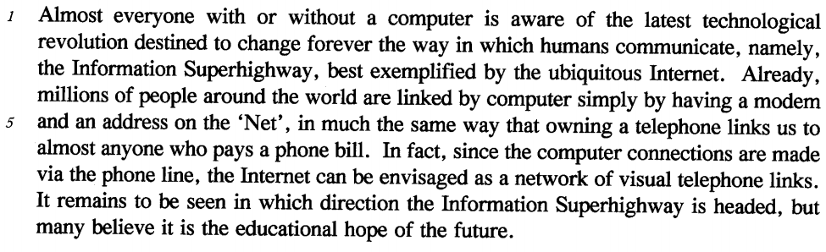
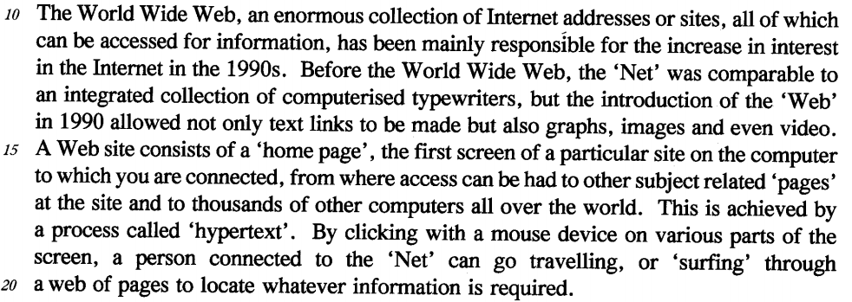
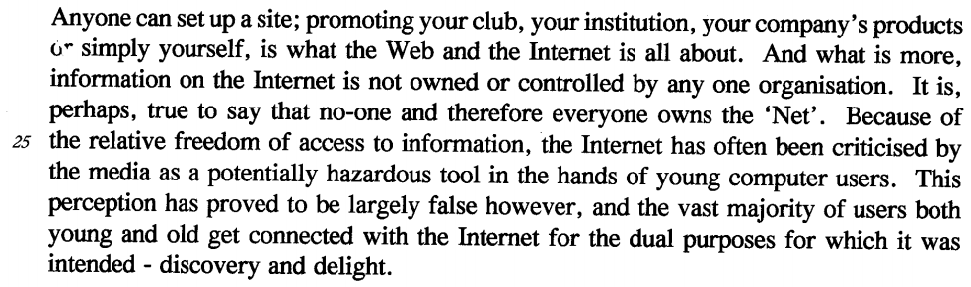
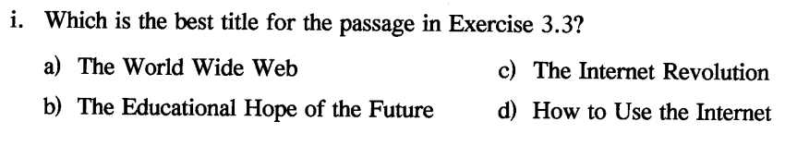
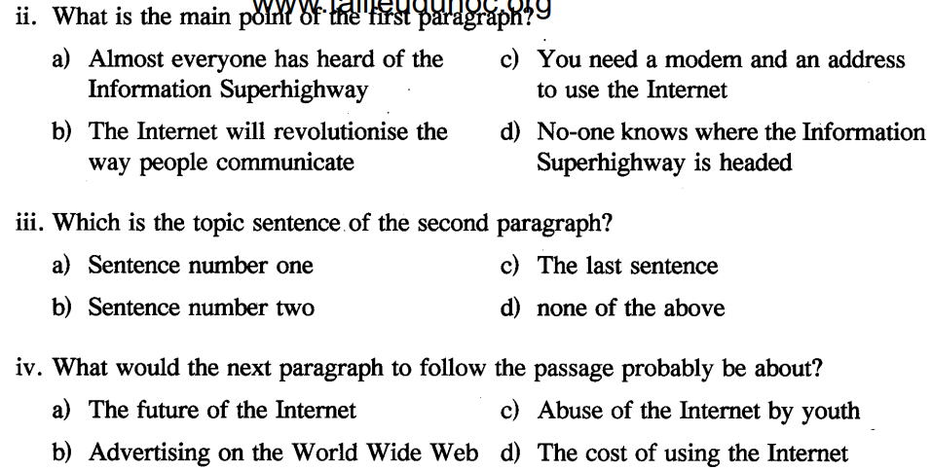
Do the following statements agree with the information give in Passage
TRUE if the statement agrees with the information
FALSE if the statement contradicts the information
NOT GIVEN if there is no information on this



